These ID’s were **not found in the Excel sheet** but had associated files



**Lowercase** directory (trivial issue)

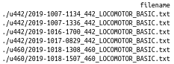

**Mislabelled/misplaced** files (directory doesn’t match ID)



* Troublesome because 271 should have had two sessions (Binned Counts1 and Binned Counts2, but the file’s data were recorded in Binned Counts1a for U371

**Raw files** that were not noted in the Excel file but were **all 0’s and NA’s** (Currently excluded from data)

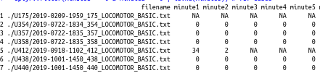

**Mislabelled sessions**

(Only found two raw files but has the space in the Excel sheet for four files)

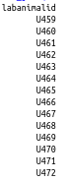

Creating graphs – could be from NA’s or points that were out of the limit bounds